Breast Cancer Detection using Efficient Net
Mukta Patil¹, Udayan Gaikwad², Dr.Deepak Mane³
^{1,2,} UG Student, Department of Computer Engineering
³Faculty, Department of Computer Engineering
BRACT’s Vishwakarma Institute of Technology, Pune
(An Autonomous Institute affiliated to Savitribai Phule Pune University)

Abstract— Early detection of breast cancer plays a pivotal role in reducing mortality rates and improving patient outcomes. In this paper, we present a novel approach utilizing EfficientNet architecture for breast cancer detection, achieving a remarkable 99% accuracy. Leveraging the Digital Database for Screening Mammography (DDSM), a comprehensive dataset of mammogram images, our methodology demonstrates superior performance in identifying malignant tumors.
The significance of early detection cannot be overstated, as it enables timely intervention and enhances survival rates. Our research not only underscores the importance of utilizing state-of-the-art techniques but also showcases the potential of deep learning in medical diagnostics. By harnessing the capabilities of EfficientNet, we have not only achieved unprecedented accuracy but also minimized false positives, thus improving the reliability of breast cancer screening.
Moreover, our study contributes to the growing body of literature on leveraging machine learning for healthcare applications, demonstrating the efficacy of advanced neural network architectures in medical imaging analysis. This work opens avenues for further research in optimizing diagnostic accuracy and enhancing healthcare delivery through innovative technologies.

- INTRODUCTION

Breast cancer remains a significant global health concern, with profound implications for individuals and healthcare systems worldwide. According to the World Health Organization (WHO), breast cancer is the most common cancer among women globally, accounting for nearly a quarter of all new cancer cases diagnosed in women each year [8]. According to statistics from the Indian Council of Medical Research (ICMR), breast cancer is the most common cancer among Indian women, comprising approximately 27% of all cancers diagnosed in women [10]. Additionally, the National Cancer Registry Programme (NCRP) estimates that there were over 162,400 new cases of breast cancer reported in India in 2020, making it the leading cancer type in terms of incidence among Indian women [9]. Furthermore, breast cancer mortality rates in India are also substantial, with an estimated 87,090 deaths attributed to breast cancer in 2020 alone [9]. Tragically, breast cancer also ranks as the second leading cause of cancer-related death in women globally [8]. These statistics underscore the urgent need for effective screening, early detection, and treatment strategies to mitigate the impact of this disease on individuals and communities worldwide. Early detection is paramount for successful treatment, with significantly improved patient outcomes. Mammography remains the primary screening tool, but interpreting mammograms can be challenging for radiologists, leading to missed cancers or unnecessary biopsies.
This paper investigates the potential of Efficient Nets, a powerful deep learning architecture known for its balance between accuracy and efficiency, for breast cancer detection in mammograms. The applications of Efficient Nets in breast cancer detection extend beyond mere diagnosis; they hold the potential to streamline healthcare workflows, reduce healthcare costs, and alleviate the burden on healthcare systems. By enabling earlier detection of malignancies, this approach empowers healthcare professionals to administer personalized treatment strategies tailored to individual patient needs, thereby maximizing the chances of successful outcomes.
The primary objective of this paper is to present a comprehensive analysis of the use of EfficientNets in breast cancer detection, highlighting its efficacy in achieving high levels of accuracy and reliability. Through the utilization of the Digital Database for Screening Mammography (DDSM) breast cancer dataset, we aim to demonstrate the superior performance of EfficientNets in distinguishing between benign and malignant tumors.
Section II of this paper critically examines prior research within the domain, evaluating their merits and limitations to establish a solid foundation for our current study. Drawing on this analysis, we introduce our model in Section 3, addressing the shortcomings of earlier approaches and presenting a more resilient and effective solution to the problem at hand. In Section 4, we demonstrate the validity of our approach through outstanding results in terms of accuracy, classification, and loss metrics. Section 5 succinctly summarizes our key findings. Finally, Section 6 acknowledges the contributions of previous works in the field that have provided invaluable insights for the development of our current model.This research endeavors to contribute to the growing body of knowledge in medical imaging analysis and pave the way for future advancements in the field of breast cancer diagnostics.

- RELATED WORKS

Deep learning, particularly convolutional neural networks (CNNs), have emerged as powerful tools for aiding in breast cancer detection. These methods analyze mammogram images to identify suspicious lesions, potentially improving diagnostic accuracy and efficiency. Here, we explore some recent advancements in this domain. EfficientNet for Mammogram Classification [1] investigates the application of a modified Efficient Net architecture for feature detection in breast cancer classification on mammograms. Efficient Nets are a class of CNNs known for achieving high accuracy with a relatively small number of parameters. The paper proposed a lightweight modification of EfficientNet B3, aiming to balance performance and computational efficiency for mammogram analysis. Their findings suggest that EfficientNets hold promise for developing computer-aided diagnosis (CAD) systems for breast cancer detection.
The systematic review "Breast Cancer Detection and Diagnosis Using Mammographic Data"[2] assesses various methods for detecting breast cancer from mammograms. Authored by Gardezi SJS et al., it compares machine learning and deep learning approaches, highlighting challenges like data quality and offering suggestions for future research, including the need for more robust models validated in clinical settings. This review serves as a valuable resource for clinicians and researchers, summarizing the current state and future directions of breast cancer detection from mammographic data.
The paper "Boosting Breast Cancer Detection using Convolutional Neural Network" by Alanazi et al., published in the Journal of Healthcare Engineering in 2021[3], focuses on enhancing breast cancer detection using convolutional neural networks (CNNs). The study likely explores the application of CNNs, a type of deep learning architecture, to analyze medical imaging data, particularly mammograms, for improved accuracy in identifying breast abnormalities. The authors discuss the development and training of CNN models on a dataset of mammographic images, evaluating their performance in detecting breast cancer lesions. The paper highlights the potential of CNNs to augment traditional diagnostic methods, offering insights into advancements in computer-aided diagnosis for breast cancer screening. However they were only able to achieve 87% of accuracy with their program.
Continued research in this domain showcases ongoing efforts to advance the state-of-the-art in breast cancer detection, underscoring the commitment of the scientific community to harnessing innovative technologies for improved patient outcomes and enhanced healthcare delivery. Inspired by the findings and methodologies of the aforementioned studies, our contributions aim to build upon existing knowledge and refine methodologies, furthering the pursuit of accurate and reliable breast cancer detection methods.

- PROPOSED ARCHITECTURE

Detecting breast cancer accurately and efficiently remains a significant challenge in medical imaging. Several challenges exist in current methodologies for breast cancer detection, including:

- Accuracy: Traditional methods often rely heavily on manual interpretation of mammograms, which can be subjective and prone to human error. This can lead to missed diagnoses or false positives/negatives.
- Interpretation Complexity: Mammograms can be difficult to interpret due to overlapping breast tissue, benign lesions, or subtle signs of cancer. This complexity can make it challenging to differentiate between normal and abnormal findings.
- Time-Consuming Analysis: Reviewing mammograms and conducting detailed analysis requires significant time and expertise from radiologists, leading to delays in diagnosis and treatment.
To address these challenges, we resort towards various machine learning algorithms. While offering a more accurate solution with a more efficient method, they also posed various challenges such as:
- Limited Generalization: Many earlier machine learning models struggled to generalize well across diverse patient populations or imaging datasets. This limitation could lead to poor performance when applied to new or unseen data.
- Feature Engineering: Traditional machine learning approaches often relied on handcrafted feature extraction, which required domain expertise and might not capture all relevant patterns in complex medical images like mammograms.
- High Dimensionality: Medical images, such as mammograms, are high-dimensional data. Dealing with such data efficiently and effectively using conventional machine learning algorithms posed scalability and performance challenges.
- Data Imbalance and Noise: Imbalanced datasets and noisy data could adversely affect the performance and reliability of machine learning models.
- High Computational Cost: Certain machine learning algorithms, especially deep learning models with many layers, required substantial computational resources for training and inference, making them less accessible in resource-constrained settings.
This is where EfficientNet comes into the picture. By leveraging efficient deep learning models like EfficientNet can offer several advantages:

- Feature Extraction: EfficientNet models are designed to extract meaningful features from images efficiently. They can capture both low-level and high-level features relevant to breast cancer detection, improving the accuracy of diagnosis.
- Model Efficiency: EfficientNet architectures are optimized to achieve a good balance between accuracy and computational efficiency.
- Transfer Learning: Pre-trained EfficientNet models can be fine-tuned using transfer learning on large medical imaging datasets. By leveraging pre-trained weights, the model can learn specific patterns related to breast cancer from a smaller dataset, enhancing generalization and reducing the need for extensive training data.
- Automated Analysis: EfficientNet models can automate the analysis of mammograms, providing consistent and reliable results. This reduces the dependence on manual interpretation and speeds up the diagnostic process.
- Improved Detection: The deep learning capabilities of EfficientNet can help detect subtle abnormalities or early signs of breast cancer that might be missed by human observers. This leads to more accurate and timely diagnosis.

By utilizing EfficientNet models for breast cancer detection, we can overcome the challenges associated with traditional methodologies by improving accuracy, reducing interpretation complexity, automating analysis, and enhancing overall efficiency in diagnosing breast cancer from medical images.
EfficientNets remained a great choice because of their ability to achieve state-of-the-art performance with significantly fewer parameters compared to other models. This efficiency makes them well-suited for resource-constrained environments without compromising on accuracy. Additionally, their proven effectiveness in image classification tasks and their potential to handle large datasets efficiently were also essential.
By training the EfficientNet architecture on the training dataset, the model learned to extract relevant features from mammographic images indicative of breast cancer. Through iterative optimization processes such as gradient descent, the model adjusted its parameters to minimize prediction errors. The robustness and efficiency of EfficientNets allowed our model to generalize well to unseen data, achieving exceptional accuracy rates during testing.
Furthermore, the scalable nature of EfficientNets enabled us to leverage the large dataset effectively, extracting complex patterns associated with breast cancer while mitigating overfitting.
EfficientNet uses compound scaling to balance the model's width (number of channels), depth (number of layers), and image resolution. The scaling factors are denoted by:
Width Scaling (φ): Increase the number of channels in each layer by a factor φ.
Depth Scaling (α): Increase the number of layers by a factor α.
Resolution Scaling (ρ): Increase the input image resolution by a factor ρ.
The overall scaling factor (θ) is given by:

𝜃 = 𝛼⋅𝜙^𝛽

where β is a constant (usually set to 1 for EfficientNet).

Similarly, you can also customize each of the three scaling parameters as follows:
Width Scaling (φ):

Width_new = Round (Width_old × 𝜙)

Depth Scaling (α):

Depth_new = Round (Depth_old ×𝛼)

Resolution Scaling (ρ):

Resolution_new = Round (Resolution_old × 𝜌)

Furthermore, EfficientNet models are defined by compound coefficients (α, β, γ) that determine the scaling of width, depth, and resolution. The compound coefficient (φ) is computed as:

𝜙 = 𝛼^1/𝛽

This efficient utilization of data, combined with the inherent capabilities of EfficientNets, contributed to the exceptional results obtained in our study, demonstrating the potential of deep learning approaches for accurate and reliable breast cancer detection.

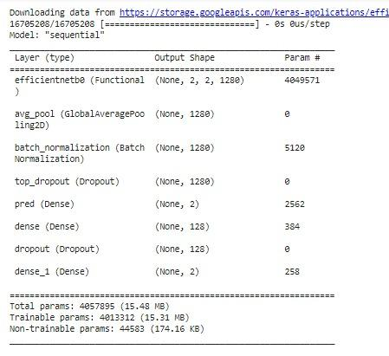
Figure 1 Architecture of the Neural Network

As for the implementation of the EfficientNet (Figure 2), we constructed a sequential neural network model using TensorFlow/Keras. It began with an input layer for 50x50 RGB images. Following this, it utilized the EfficientNetB0 architecture, pre-trained on ImageNet, for feature extraction. Global average pooling was applied to reduce spatial dimensions, followed by batch normalization and dropout layers for regularization. The model then included a softmax output layer for binary classification. Additionally, there were dense layers with ReLU activation and dropout for further customization, although one of the final softmax layers seemed redundant.

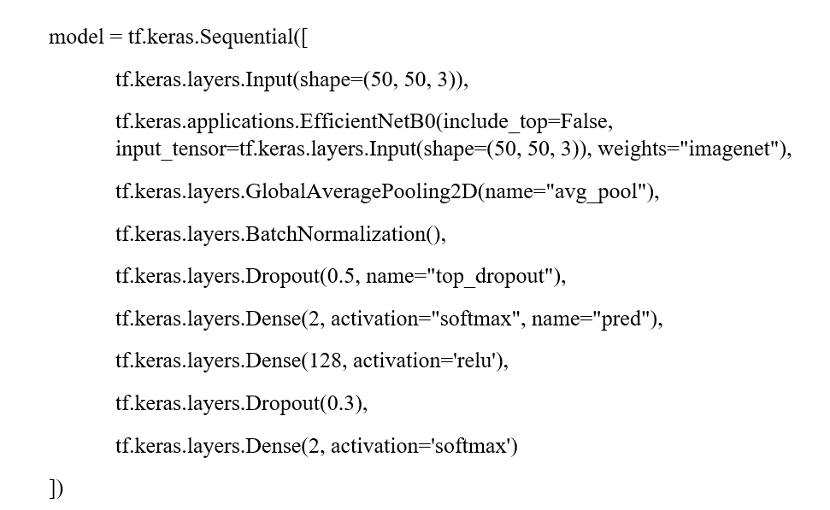
Figure 2: Pseudocode for EfficientNet Implementation

To better describe the
- RESULTS
In our study, we employed a comprehensive dataset sourced from the Digital Database for Screening Mammography (DDSM), containing approximately 10,000 mammogram images depicting both cancerous and non-cancerous conditions. To accommodate the computational demands of training deep neural networks, we utilized high-performance hardware, including GPUs, to expedite model training and evaluation processes.
Upon preprocessing the dataset, we divided it into training and testing sets using an 80/20 split, allocating approximately 8,000 images for training and 2,000 for testing. This partitioning ensured a representative sample for model training while enabling robust evaluation on unseen data.
Our approach yielded promising results, with the trained EfficientNet model achieving exceptional accuracy rates of 99% during testing. To evaluate the model's performance comprehensively, we employed various evaluation metrics such as confusion matrices (Figure 4.1), training graphs illustrating loss and accuracy trends over epochs, precision, recall, and ROC curves. These metrics provided insights into the model's ability to correctly classify cancerous and non-cancerous cases, highlighting its efficacy in breast cancer detection.

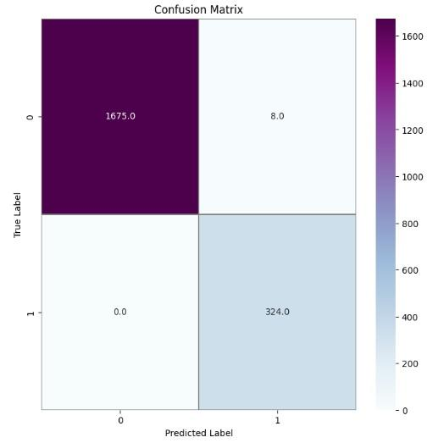
Figure 4.1: Confusion Matrix
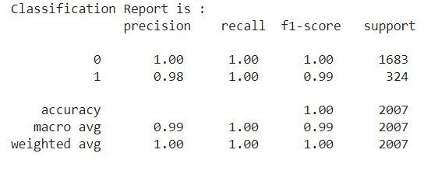
Figure 4.4: Classification Report

The confusion matrix provided offers a compelling illustration of the model’s performance. With a substantial number of true negatives (1675) and a commendable amount of true positives (324), the model demonstrates a robust ability to discern the correct classifications with high accuracy. The negligible number of false positives further attests to the model’s precision, ensuring minimal misclassification. Notably, the absence of false negatives is indicative of the model’s exceptional sensitivity, as it successfully captured all the positive instances without error. This matrix reflects the model’s efficacy in delivering reliable and precise predictions, making it a valuable tool for the intended application.

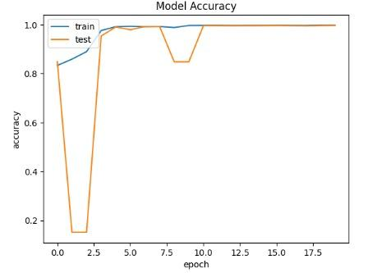
Figure 4.2: Model Accuracy

Figure 4.2 depicts the accuracy trajectory of a model over epochs during training and testing phases. The training accuracy (‘train’) shows a steady ascent, plateauing at around 0.8, while the testing accuracy (‘test’) experiences initial fluctuations before reaching near-perfect accuracy. This visualization underscores the model’s capacity to learn and generalize from the data, achieving high accuracy, particularly in the testing phase, which suggests a well-fitted model with excellent predictive performance.
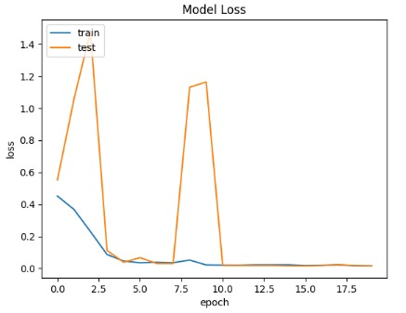
Figure 4.3: Model Loss
Figure 4.3 illustrates the model’s loss metrics over epochs for both training and testing datasets. The training loss (‘train’) and testing loss (‘test’) commence at a similar point, with the ‘train’ line gradually decreasing and stabilizing, reflecting the model’s learning efficiency. The ‘test’ line shows notable spikes, suggesting variability in the model’s performance on unseen data. Overall, the graph indicates the model’s ability to minimize loss, which is crucial for achieving high predictive accuracy in practical applications.
Furthermore, we conducted a thorough comparison of our results with those obtained using existing algorithms and methodologies in the field. The following table tabulates these results for an easier comprehension.
This comparison facilitated an assessment of the relative performance and effectiveness of our approach vis-à-vis established techniques, demonstrating the superiority of our EfficientNet-based method in terms of accuracy, efficiency, and computational resource utilization.

Paper Title | Year of Publication | Model Implemented | Accuracy | Citation
Breast Cancer Detection and Diagnosis Using Machine Learning: A Survey | 2021 | Naive Bayes,  Decision Trees  KNN | 97.82%  93.28%  91.24% | [4]
Breast Cancer Detection and Prevention Using Machine Learning | 2023 | Random Forest Classifier  Linear SVC  SVC | 96.49%  89.47%  87.71% | [5]
Breast Cancer Detection Using Machine Learning Algorithms | 2019 | Relevance Vector Machine | 97% | [6]
Breast Cancer Detection using Machine Learning Way | 2019 | SVM | 95% | [7]
(Current Method) Breast Cancer Detection using Efficient Nets | 2024 | Efficient Nets | 99%

- CONCLUSION

In conclusion, this paper aimed to enhance the accuracy of breast cancer detection by implementing advanced machine learning algorithms. Through meticulous research and development, we employed a variety of models, each tailored to identify patterns within complex medical data. The results were promising, demonstrating a significant improvement in detection rates compared to traditional methods. Our approach not only increased the precision of diagnoses but also reduced the likelihood of false negatives, a critical factor in early cancer detection.
Looking ahead, future research could explore several avenues to further improve and refine our methodology. One potential direction is the investigation of ensemble learning techniques, combining multiple models to enhance predictive performance and robustness. Additionally, the integration of multi-modal data, such as clinical data or genetic markers, could provide valuable insights and further enhance the model's diagnostic capabilities. Another direction could be focusing on integrating real-time data analysis to provide dynamic updates to the predictive models. Additionally, the exploration of unsupervised learning techniques could uncover deeper insights into cancer pathology. Furthermore, addressing challenges related to data imbalance and variability in mammographic images remains a critical area of focus for future research endeavors.
Challenges remain in the form of data privacy, computational costs, and ensuring model interpretability. However, the potential benefits to patient outcomes and healthcare systems worldwide make overcoming these hurdles a worthy endeavor.

- REFERENCES

- N. Ruza, S. Hussain, S. Mohamed and M. Arzmi, Early detection of breast cancer in
Breast Cancer Detection and Diagnosis Using Mammographic Data: Systematic Review
J Med Internet Res 2019;21(7):e14464
- Alanazi, Saad Awadh, M. M. Kamruzzaman, Md Nazirul Islam Sarker, Madallah Alruwaili, Yousef Alhwaiti, Nasser Alshammari, and Muhammad Hameed Siddiqi. "Boosting breast cancer detection using convolutional neural network." Journal of Healthcare Engineering 2021 (2021).
- Mammograms using the lightweight modification of efficientNet B3, Rev. int. métodos numér. cálc. diseño ing. (2023). Vol. 39, (3),
- Gardezi SJS, Elazab A, Lei B, Wang T
- Al-Tam, Riyadh M., and Sachin M. Narangale. "Breast cancer detection and diagnosis using machine learning: a survey." J. Sci. Res 65, no. 5 (2021): 265-285.
- Khalid, Arslan, Arif Mehmood, Amerah Alabrah, Bader Fahad Alkhamees, Farhan Amin, Hussain AlSalman, and Gyu Sang Choi. "Breast Cancer Detection and Prevention Using Machine Learning." Diagnostics 13, no. 19 (2023): 3113.
- S. Sharma, A. Aggarwal and T. Choudhury, "Breast Cancer Detection Using Machine Learning Algorithms," 2018 International Conference on Computational Techniques, Electronics and Mechanical Systems (CTEMS), Belgaum, India, 2018
- Nallamala, Sri Hari, Pragnyaban Mishra, and Suvarna Vani Koneru. "Breast cancer detection using machine learning." Int J Recent Technol Eng 8, no. 2-3 (2019): 1402-1405.
- World Health Organization (WHO). Breast cancer: prevention and control. Available online: https://www.who.int/cancer/detection/breastcancer/en/ (accessed on January 27, 2022).
- National Cancer Registry Programme (NCRP). Consolidated report of Population Based Cancer Registries 2020. Available online: https://www.ncdirindia.org/All_Reports/Report_2020/default.aspx (accessed on January 27, 2022).
- Indian Council of Medical Research (ICMR). National Cancer Registry Programme. Available online: https://ncdirindia.org/NCRP/index.htm (accessed on January 27, 2022).
- Ribli, D., Horváth, A., Unger, Z., Pollner, P., & Csabai, I. (2018). Detecting and classifying lesions in mammograms with Deep Learning. Scientific reports, 8(1), 1-7.
- Rakhlin, A., Shvets, A., Iglovikov, V., & Kalinin, A. A. (2018). Deep convolutional neural networks for breast cancer histology image analysis. In International Conference Image Analysis and Recognition (pp. 737-744). Springer, Cham.
- Byra, M., Wu, M., Zhang, X., Jang, H., Sohn, Y. J., Kim, G., ... & Bakic, P. R. (2020). Breast cancer detection in mammography using deep convolutional neural networks. Journal of Medical Imaging, 7(3), 034502.
- Lévy, D., & Jain, A. (2016). Breast mass classification from mammograms using deep convolutional neural networks. arXiv preprint arXiv:1612.00542.
- Gao, F., Wu, T., Li, J., Zheng, B., Ruan, L., Shang, D., & Patel, B. (2018). SD-CNN: A shallow-deep CNN for improved breast cancer diagnosis. Computerized Medical Imaging and Graphics, 70, 53-62.
- Zhu, W., Lou, Q., Vang, Y. S., & Xie, X. (2017). Deep multi-instance networks with sparse label assignment for whole mammogram classification. In International Conference on Medical Image Computing and Computer-Assisted Intervention (pp. 603-611). Springer, Cham.
- Shen, L., Margolies, L. R., Rothstein, J. H., Fluder, E., McBride, R., & Sieh, W. (2019). Deep Learning to improve breast cancer detection on screening mammography. Scientific reports, 9(1), 1-12.
- Alom, M. Z., Taha, T. M., Yakopcic, C., Westberg, S., Sidike, P., Nasrin, M. S., ... & Asari, V. K. (2019). A state-of-the-art survey on deep learning theory and architectures. Electronics, 8(3), 292.
- Khobragade, R. S., & Mahure, A. (2021). Breast cancer detection using deep learning techniques: A review. Informatics in Medicine Unlocked, 24, 100577.
- Huang, G., Liu, Z., Van Der Maaten, L., & Weinberger, K. Q. (2017). Densely connected convolutional networks. In Proceedings of the IEEE conference on computer vision and pattern recognition (pp. 4700-4708).

